

IT3030 Programming Applications and Frameworks

**Group Project**

**Assignment 1**

Group Number : S1.151.3_WD

|  |  |
| --- | --- |
| **Name** | **IT Number** |
| IT18185294 | Pinto H. S. M. |
| IT18041880 | Kirindegamaarchchi M. C. |
| IT18154986 | S. M. P. U. Sakalasuriya |
| IT17100458 | M. V. N. Dissanayaka |
| IT1815986 | H. P. A. W. Kumara |

**HealthCare is a hospital management system**

Given Scenario

HealthCare is a hospital management system where the registered users can make appointments with the registered doctors who visit the registered hospitals. The users can even make the payments for the appointments online.

According to that Scenario, we divided five functions to develop this system properly and easily.

The functions are :

* + Hospital Management functions
  + Doctor Management Function
  + Patient Management Function
  + Appointment Management Function
  + Payment Management Function.

Sample description of the system we create

Patient Management Function

According to that function, the First patient must register into the system. In the registration process all user details add to the system, Registered User has User_ID that will be auto-generated one.

ER diagram

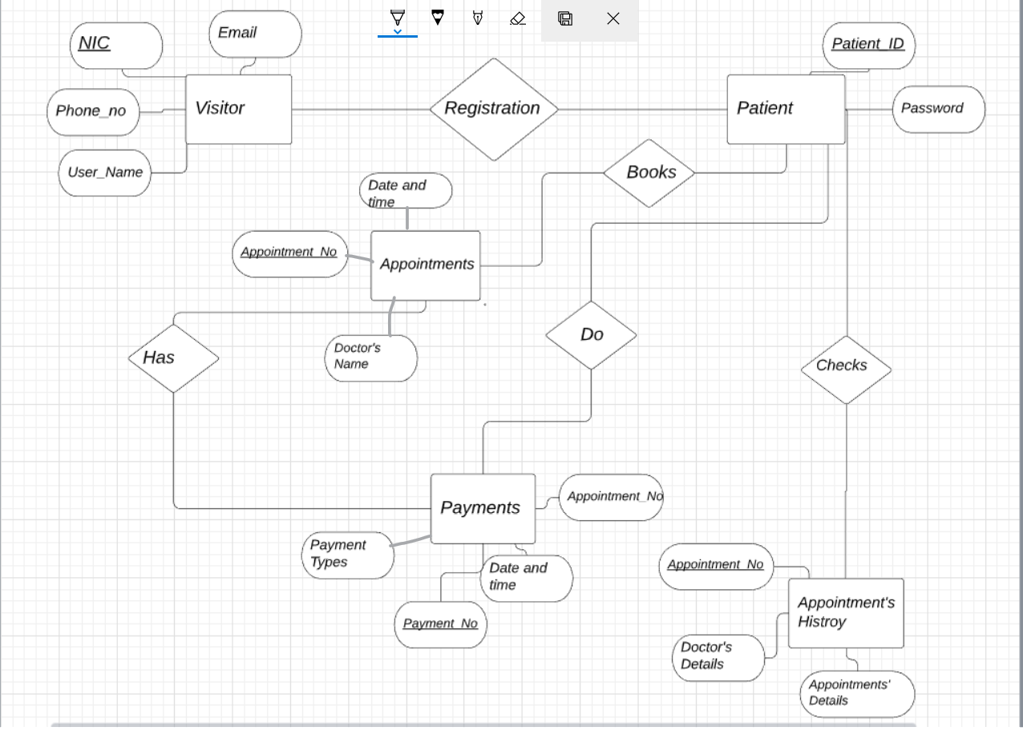

Class Diagram

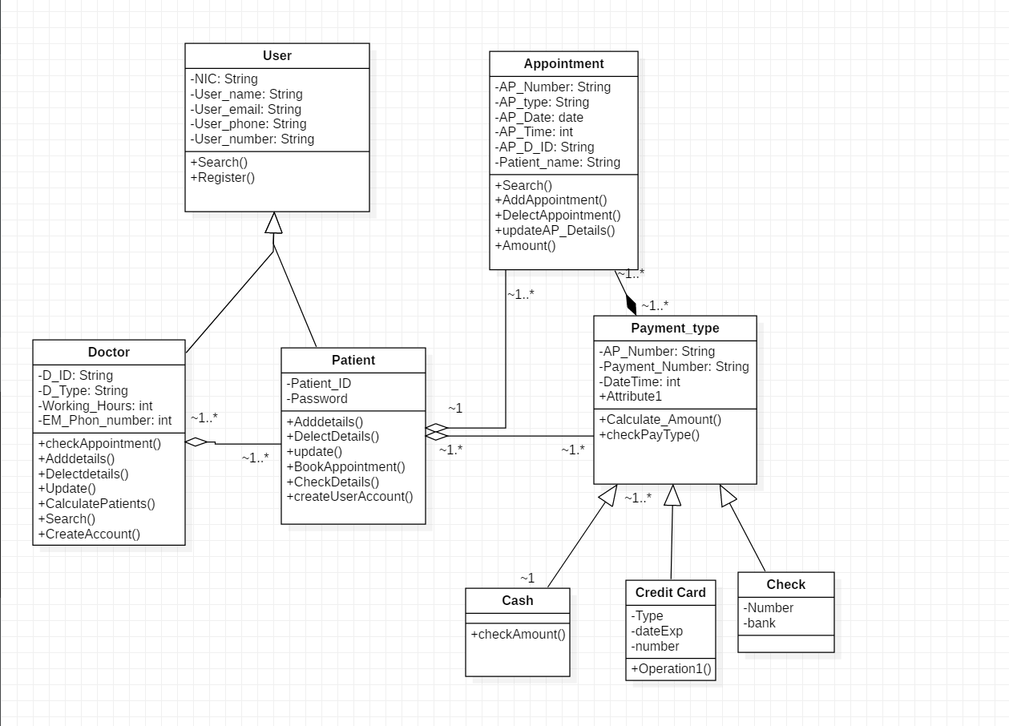

User Interface

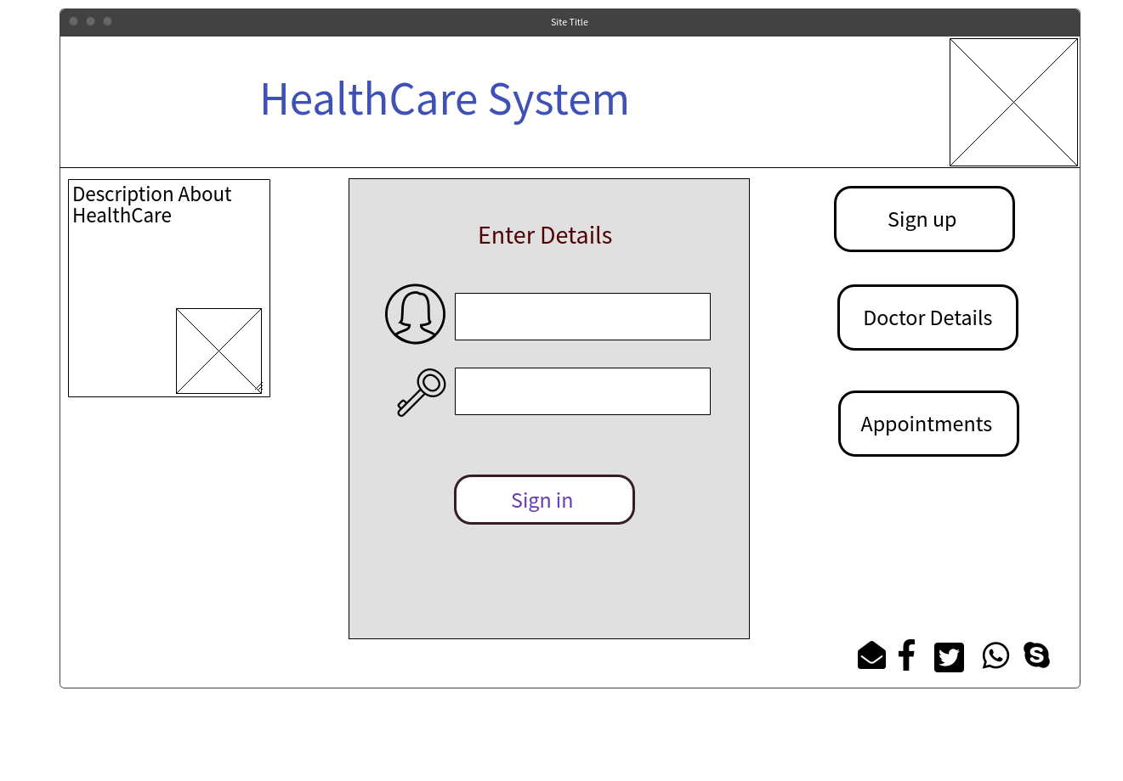

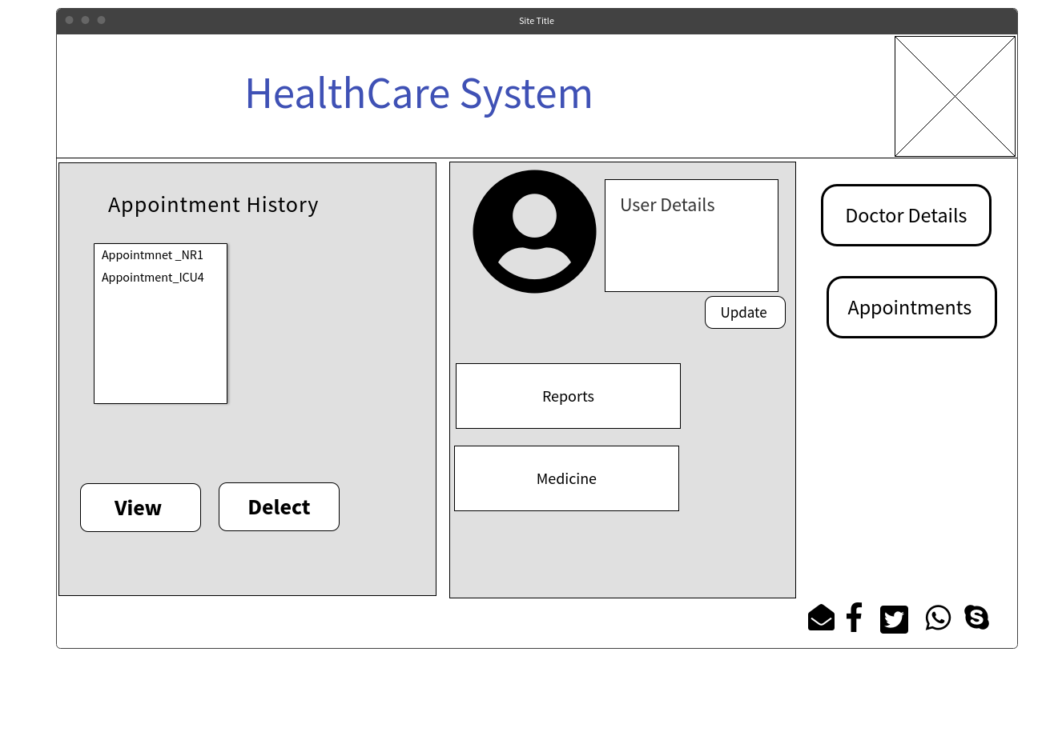

Reference

[https://examples.javacodegeeks.com/desktop-java/ide/eclipse/eclipse-web-development- tutorial/](https://examples.javacodegeeks.com/desktop-java/ide/eclipse/eclipse-web-development-%20%20tutorial/)

<https://docs.oracle.com/javaee/6/tutorial/doc/bnayl.html>

<https://mkyong.com/tutorials/jax-ws-tutorials/>

<https://javaee.github.io/tutorial/jaxws002.html>

<https://www.devdungeon.com/content/tomcat-tutorial>